**2019103573 CN LAB - 12 SACHIN RAGHUL T**

**DISTANCE VECTOR ROUTING**

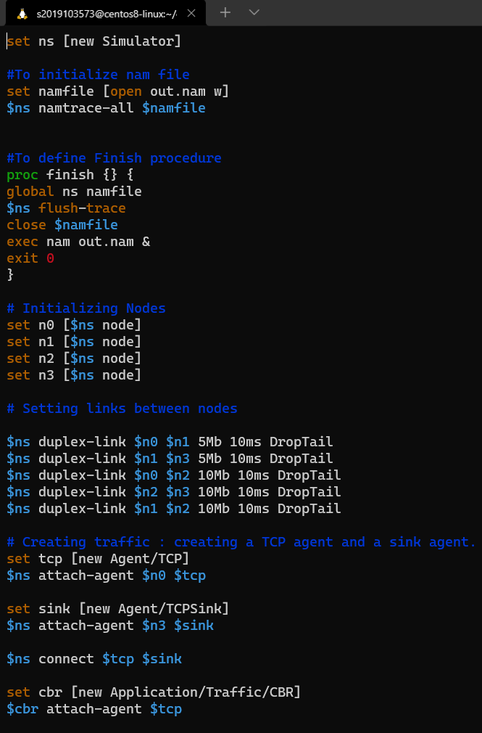

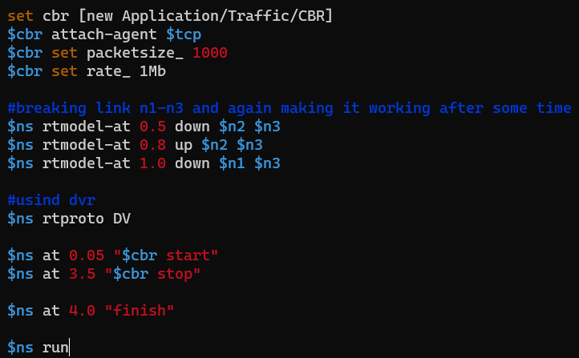

**OUTPUT :**

